**Available**

Power BI is Software as a Service (SaaS) that provides 99.9% uptime with fast deployment in cloud or hybrid cloud + on-premises scenarios.

### Scalable

Enjoy scalability at the speed of SaaS to the needs of your business, with optimized costs that are based on the number of users and their specific data needs.

### Flexible

Connect to all of your data, whether in the cloud or on-premises via live connections or scheduled refresh through the [enterprise gateway](https://powerbi.microsoft.com/documentation/powerbi-gateway-enterprise/) to provide your users with the latest insights no matter where the data lives

## Power BI is easy to manage and deploy

Optimize investment in ETL tools and infrastructure through Power BI's built-in connectivity to a variety of data sources, both in the cloud and on-premises.

Secure who gets access to what data in Power BI using [row-level security](https://powerbi.microsoft.com/blog/power-bi-service-march-update-part-two/) in combination with your existing Azure and Office 365 investment.

Standardize how dashboards, reports, and datasets are shared across the entire organization in a consistent and secured way with organizational content packs.

Deploy Power BI service with ease at the speed of SaaS and deploy Power BI Desktop the companion authoring tool using your existing deployment infrastructure and process.

Power bi is software as a service. There are three important cloud services that we know: amazon web services, the second is GCP- google cloud service and the third is azure which is my Microsoft. Power Bi is known as saas. AWS- infrastructure as a service.

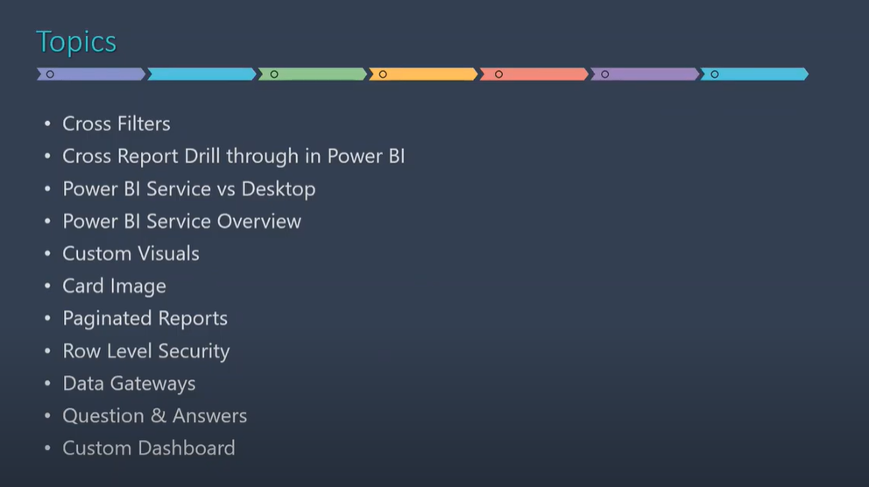

# How visuals **cross-filter** each other in a Power BI report

One of the great features of Power BI is the way all visuals on a report page are interconnected. If you select a data point on one of the visuals, all the other visuals on the page that contain that data change, based on that selection.

Cross filter becomes possible due to the relationships that are established in the tables in the data models.

### Cross-filtering and cross-highlighting

Cross-filtering and cross-highlighting can be useful to identify how one value in your data contributes to another. The terms cross-filter and cross-highlight are used to distinguish the behavior described here from what happens when you use the **Filters** pane to filter and highlight visuals.

Let's define these terms as we look at the report pages below. The "Total category volume by segment" doughnut chart has two values: "Moderation" and "Convenience".

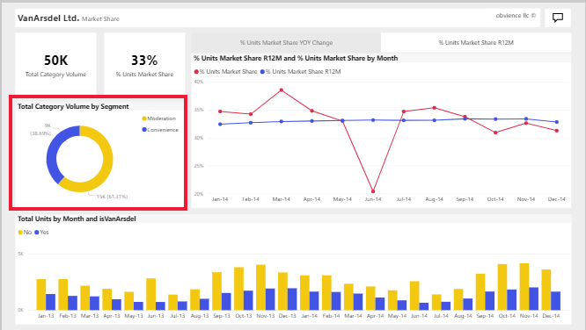

1. Let's see what happens when we select **Moderation**.

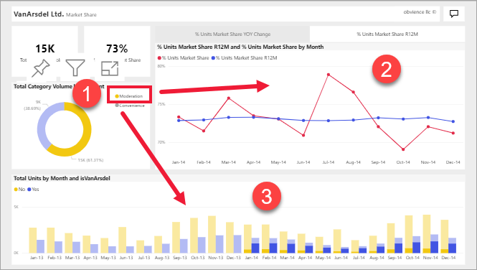

1. **Cross-filtering** removes data that doesn't apply. Selecting **Moderation** in the doughnut chart cross-filters the line chart. The line chart now only displays data points for the Moderation segment.
2. **Cross-highlighting** retains all the original data points but dims the portion that does not apply to your selection. Selecting **Moderation** in the doughnut chart cross-highlights the column chart. The column chart dims all the data that applies to the Convenience segment and highlights all the data that applies to the Moderation segment.

### Use cross-report drill through in Power BI

With the Power BI cross-report drill-through feature, you can contextually jump from one report to another report in the same Power BI service workspace or app. You can use cross-report drill through to connect two or more reports that have related content, and to pass filter context along with the cross-report connection.

In drill through, we had source report(dashboard) and target report(product sales) in the same workbook but using cross report we can implement drill through between different workbooks.

Step 1: Create another workbook. Import the data.

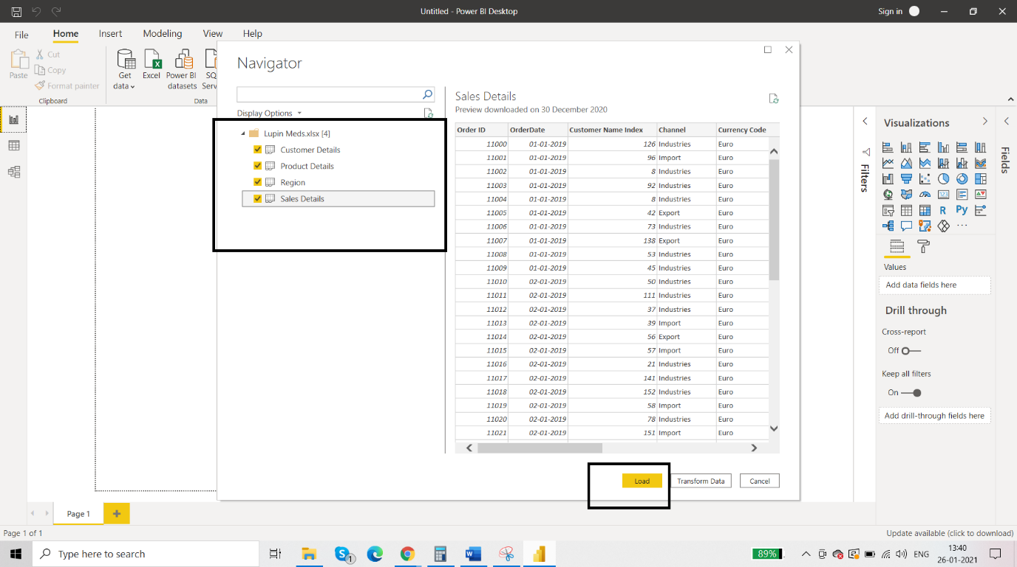

Step 2: Establish the relationships.

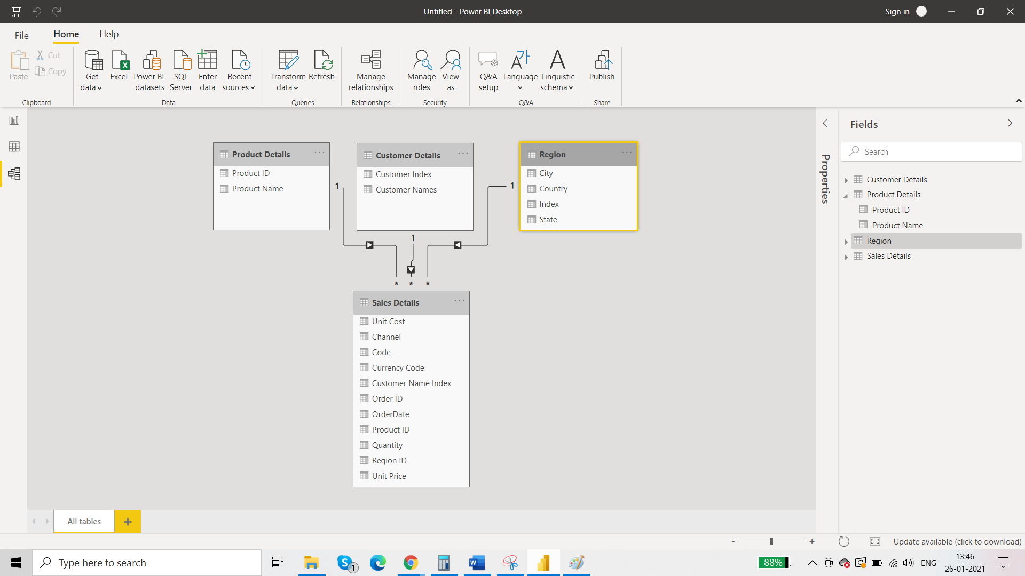

Step 3: Report view

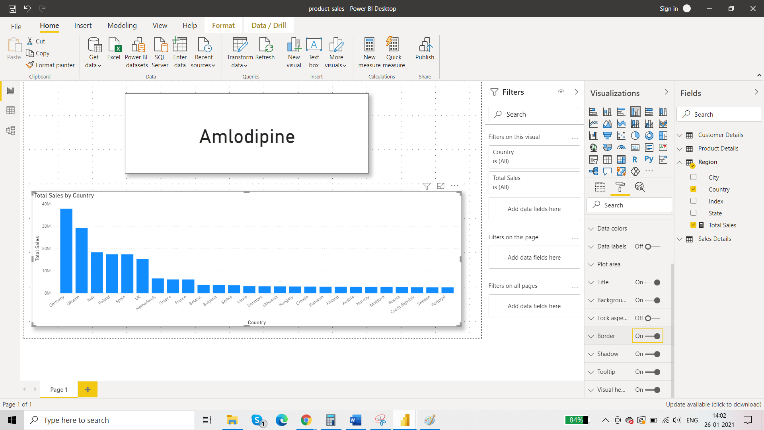

Step 4: bring the product name in drill through

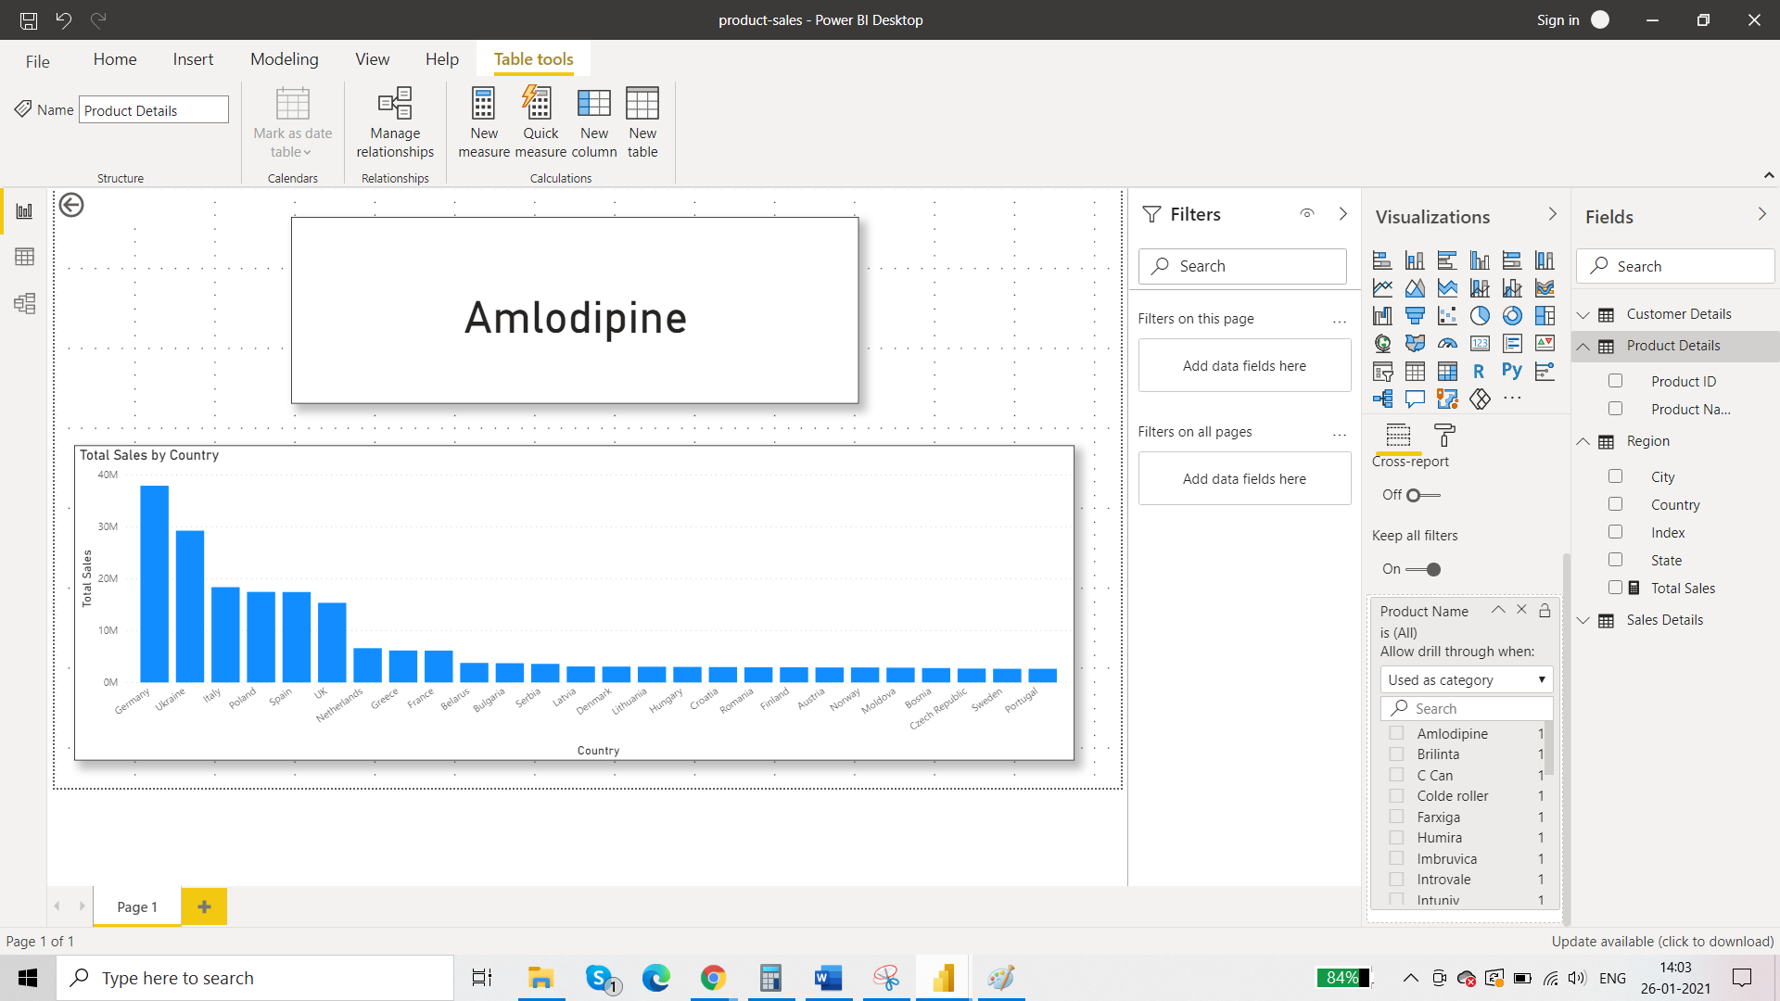

This is the target report that we have created. So cross report option is **enabled** here and not in the other dashboard because this is the target report. In the source report the cross report option is disabled.

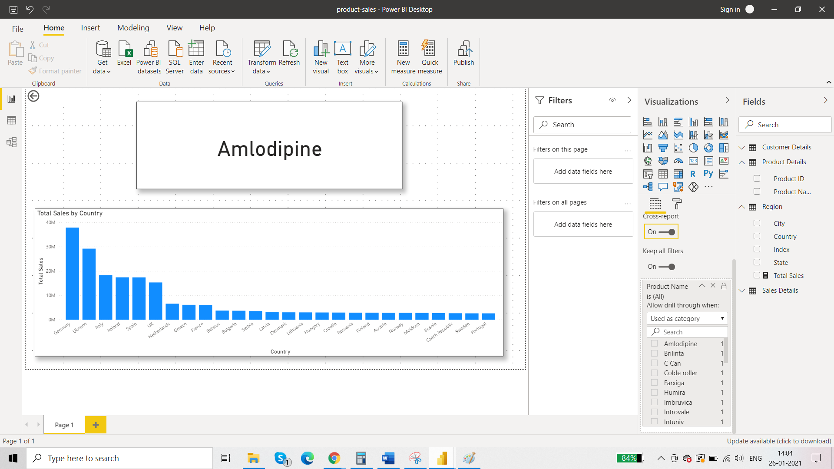

## Step 5: Enable cross-report drill through

1. In Power BI Desktop, go to **File** > **Options and settings** > **Options**.
2. In the **Options** window left navigation, at the bottom of the **Current file** section, select **Report settings**.
3. At bottom right, under **Cross-report drill through**, select **Allow visuals in this report to use drill-through targets from other reports**.
4. Select **OK**.

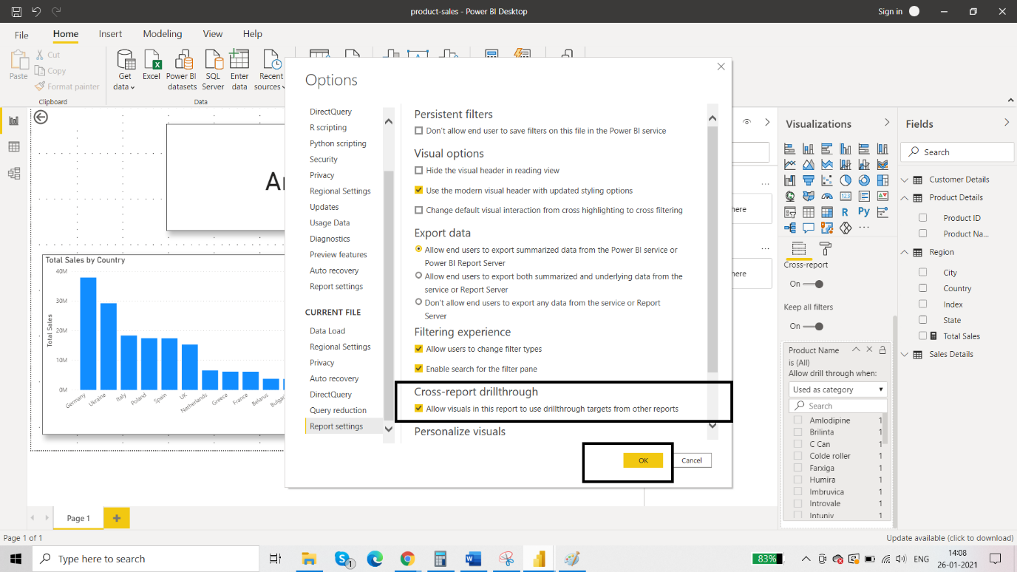

Do the same in the source book.

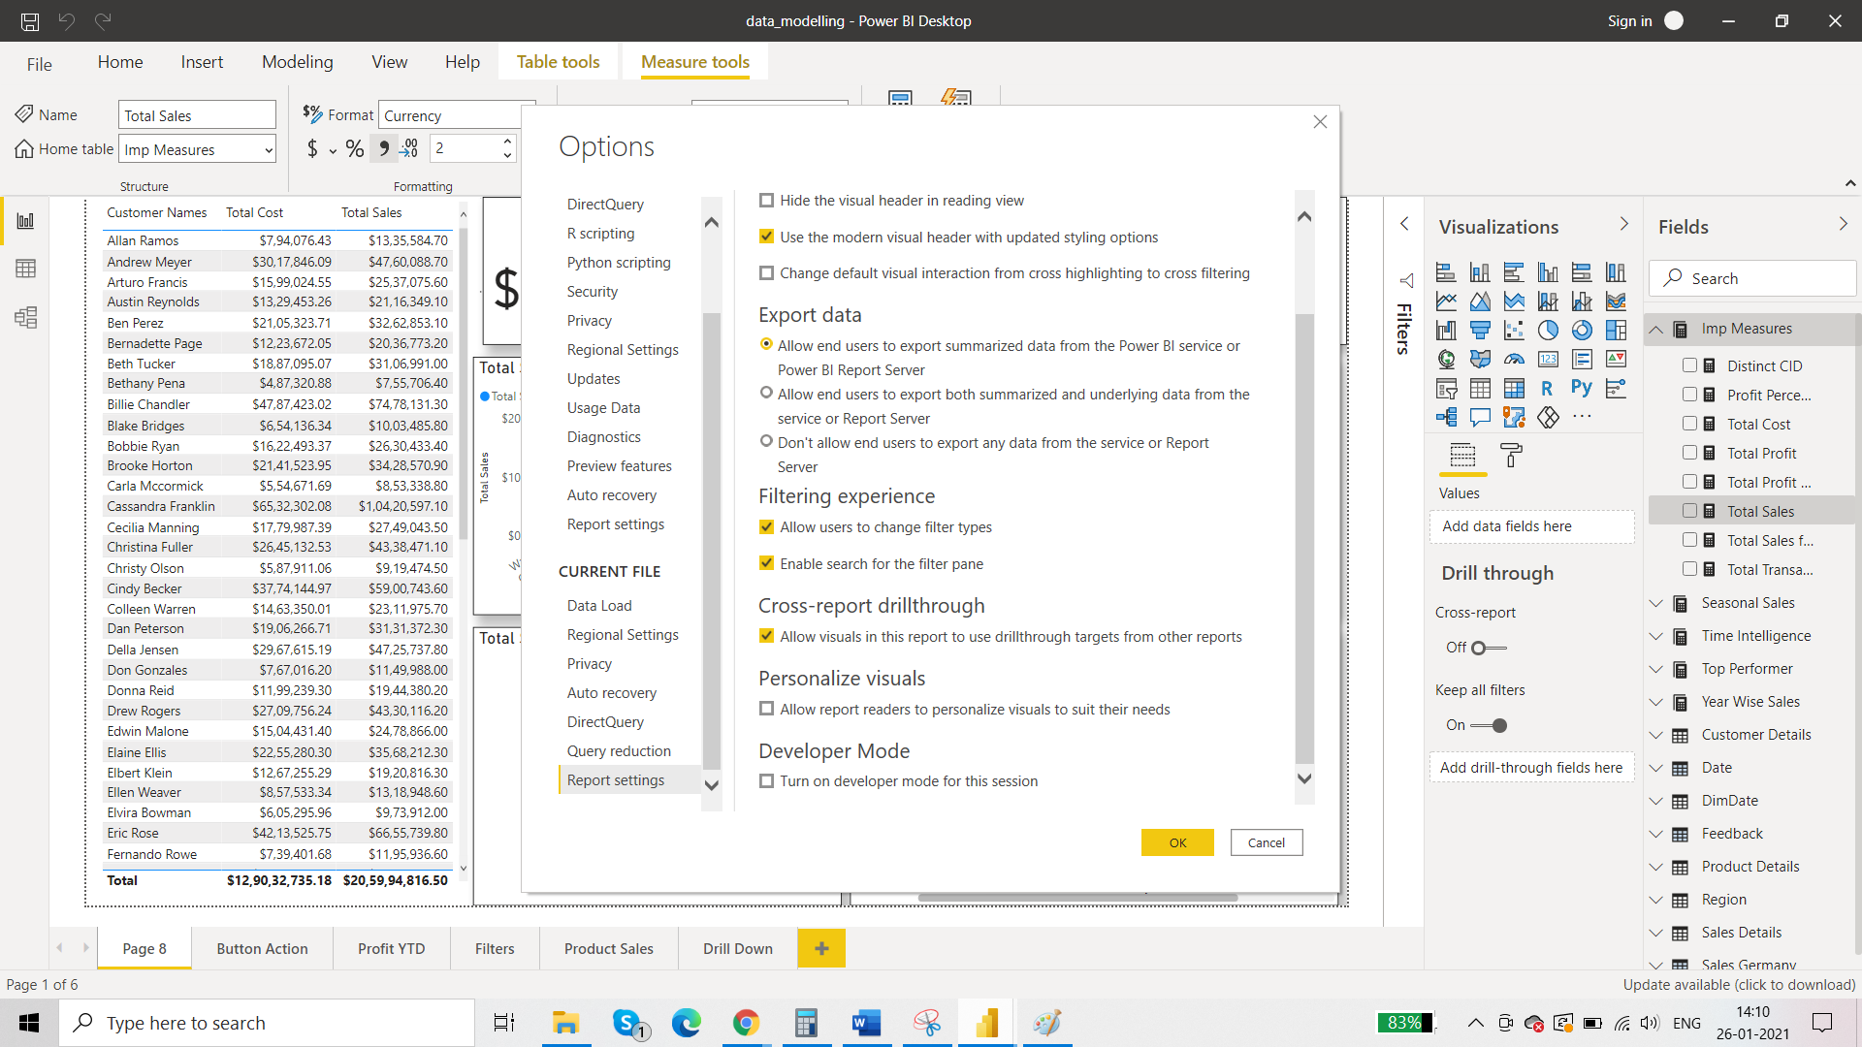

Then following steps involve publishing the report to power bi service.

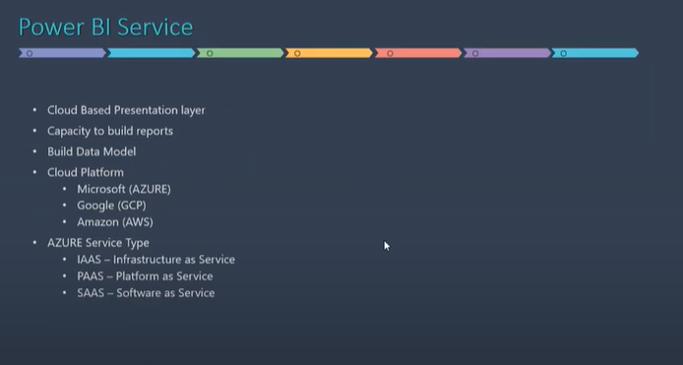

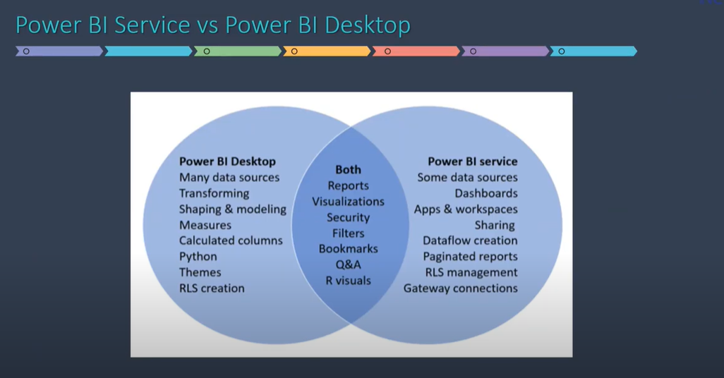

Publish the reports to power bi service and drill through option will be enables for cross report.

# **Add comments to a dashboard or report**

## How to use the Comments feature

Comments can be added to an entire dashboard, to individual visuals on a dashboard, to a report page, to a paginated report, and to individual visuals on a report page. Add a general comment or add a comment targeted at specific colleagues.

When you add a comment to a report, Power BI captures the current filter and slicer values and creates a [bookmark](https://docs.microsoft.com/en-us/power-bi/consumer/end-user-bookmarks). This means that when you select or respond to a comment, the report page or report visual may change to show you the filter and slicer selections that were active when the comment was first added.



Why is this important? Say a colleague applied a filter that revealed an interesting insight that they want to share with the team. Without that filter selected, the comment might not make sense.

If you are using a paginated report, you may only leave a general comment about your report. Support for leaving comments on individual paginated report visuals is not available.

### Add a general comment to a dashboard or report

The process for adding comments to a dashboard or report is similar. In this example, we're using a dashboard.

1. Open a Power BI dashboard or report and select the **Comment** icon. This opens the Comments dialog.

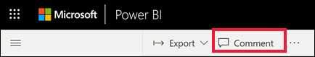

Here we see that the dashboard creator has already added a general comment. Anyone with access to this dashboard can see this comment.

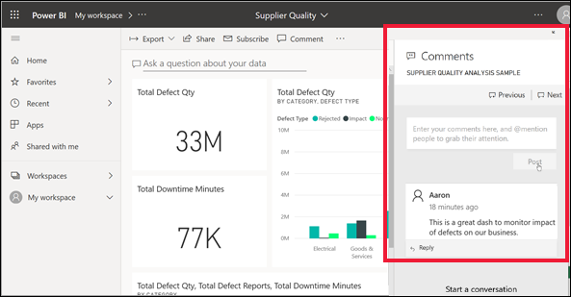

1. To respond, select **Reply**, type your response, and select **Post**.

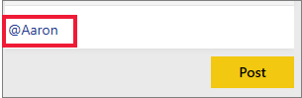

By default, Power BI directs your response to the colleague who started the comment thread, in this case Aaron.

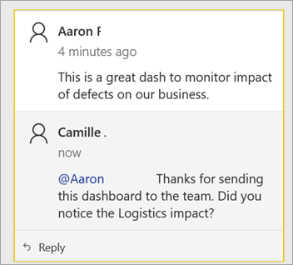

1. If you want to add a comment that is not part of an existing thread, enter your comment in the upper text field.

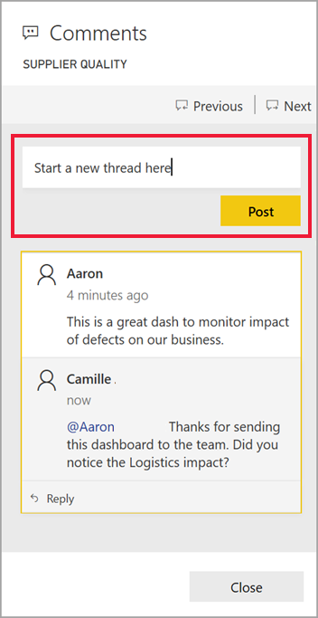

The comments for this dashboard now look like this.

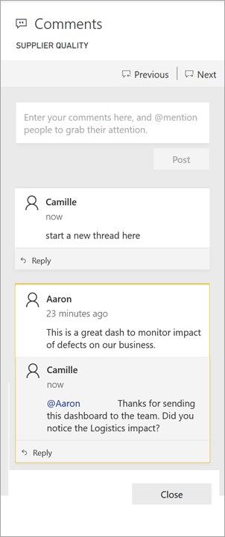

### Add a comment to a specific dashboard or report visual

In addition to adding comments to an entire dashboard or to an entire report page, you can add comments to individual dashboard tiles and individual report visuals. The processes are similar, and in this example we're using a report.

1. Hover over the visual and select **More actions** (...).
2. From the dropdown, select **Add a comment**.

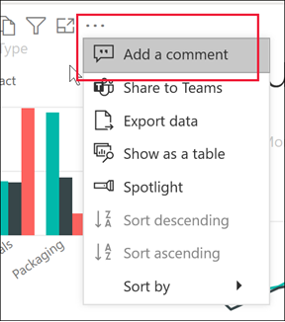

1. The **Comments** dialog opens, and the other visuals on the page are greyed out. This visual doesn't have any comments yet.

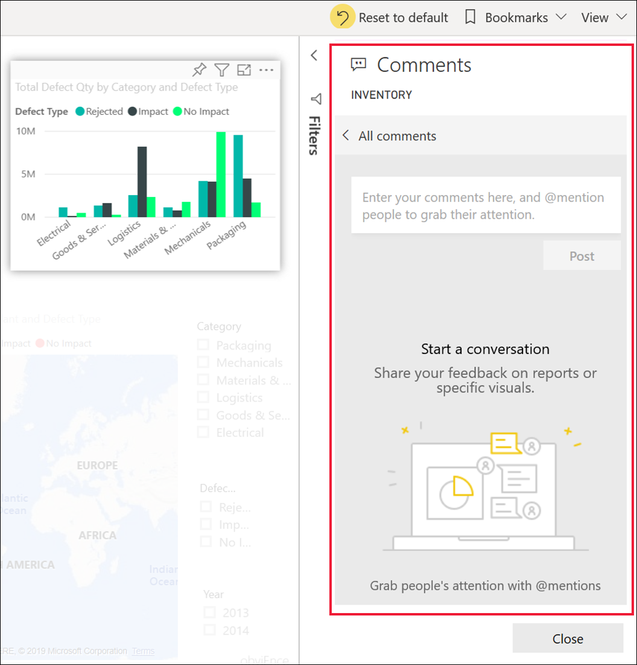

1. Type your comment and select **Post**.

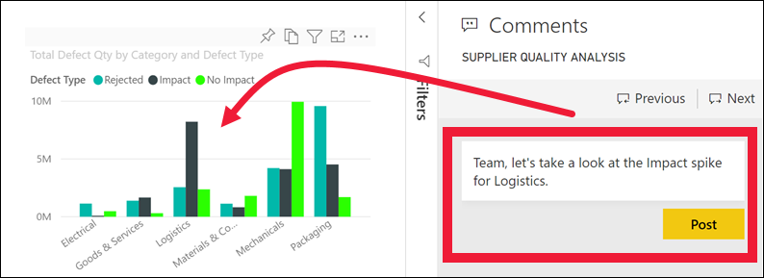

* + On a report page, selecting a comment that was made on a visual, highlights that visual (see below).
  + On a dashboard, the chart icon  lets us know that a comment is tied to a specific visual. Comments that apply to the entire dashboard do not have a special icon. Selecting the chart icon highlights the related visual on the dashboard.

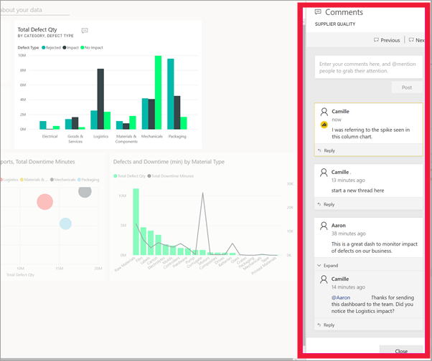

1. Select **Close** to return to the dashboard or report.

### Get your colleagues attention by using the @ sign

Whether you're creating a dashboard, report, tile, or visual comment, grab your colleagues' attention by using the "@" symbol. When you type the "@" symbol, Power BI opens a dropdown where you can search for and select individuals from your organization. Any verified name prefaced with the "@" symbol, appears in blue font. The @mentioned individuals will immediately receive an e-mail in their inbox, and if they are using a Power BI Mobile app, they will receive a push notification on their device. They can open the report or dashboard directly from the notification, see the comment, view the data, and reply accordingly.

Here's a conversation I'm having with the visualization designer. They are using the @ symbol to ensure I see the comment. I receive a notification and select the link to open this dashboard and the relevant conversation.

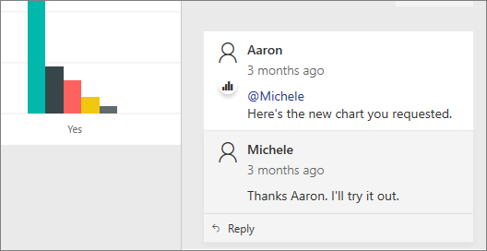

## Considerations and troubleshooting

* Bookmarks are not captured when you reply to a conversation. Only the first comment in a conversation creates a bookmark.
* If you are using a paginated report, you may only leave a general comment about your report. Support for leaving comments on individual paginated report visuals is not available.

**Paginated report Builder**

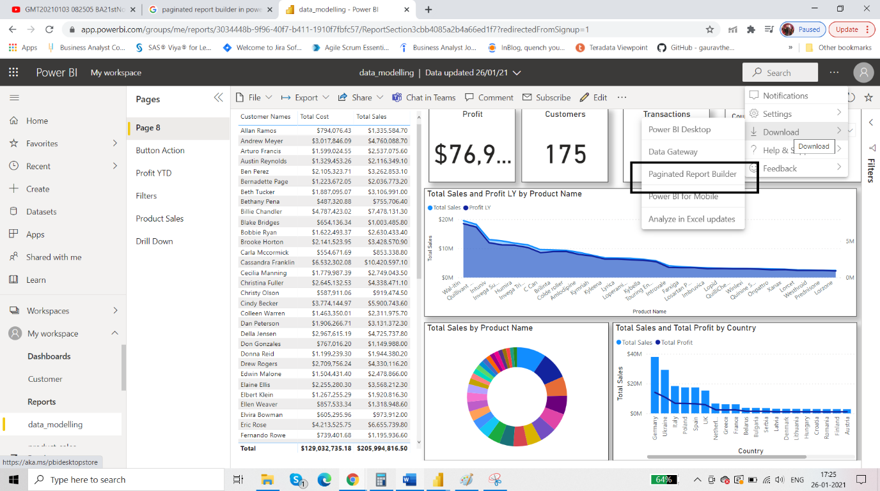

When you export the report using pdf then the exact page will be downloaded in pdf format and the text table which has scroll bar or any other visual will be incompletely shown in the pdf download. So paginated report builder will solve this problem. For example the text table which has scroll bar will be completely shown.

Instead of one page, there will be multiple pages as per the scroll bar extension. Paginated report builder is another product and can be installed separately.

**Custom Visuals in Power BI**

First, you need to have a organisational account.

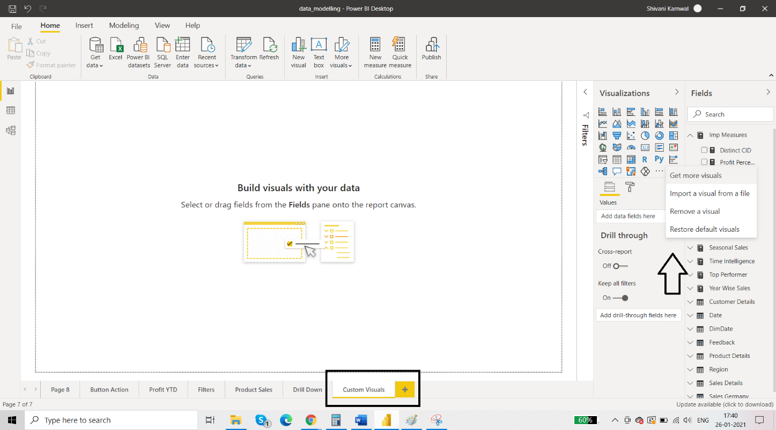

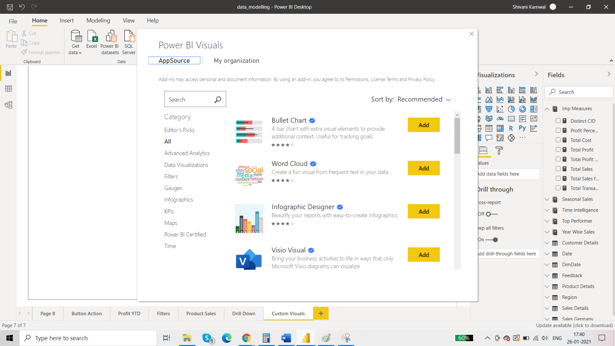

These are all free visuals. You can read about them and click add. They will be imported in the power bi desktop application.

Sunbursts: implementation of custom visual

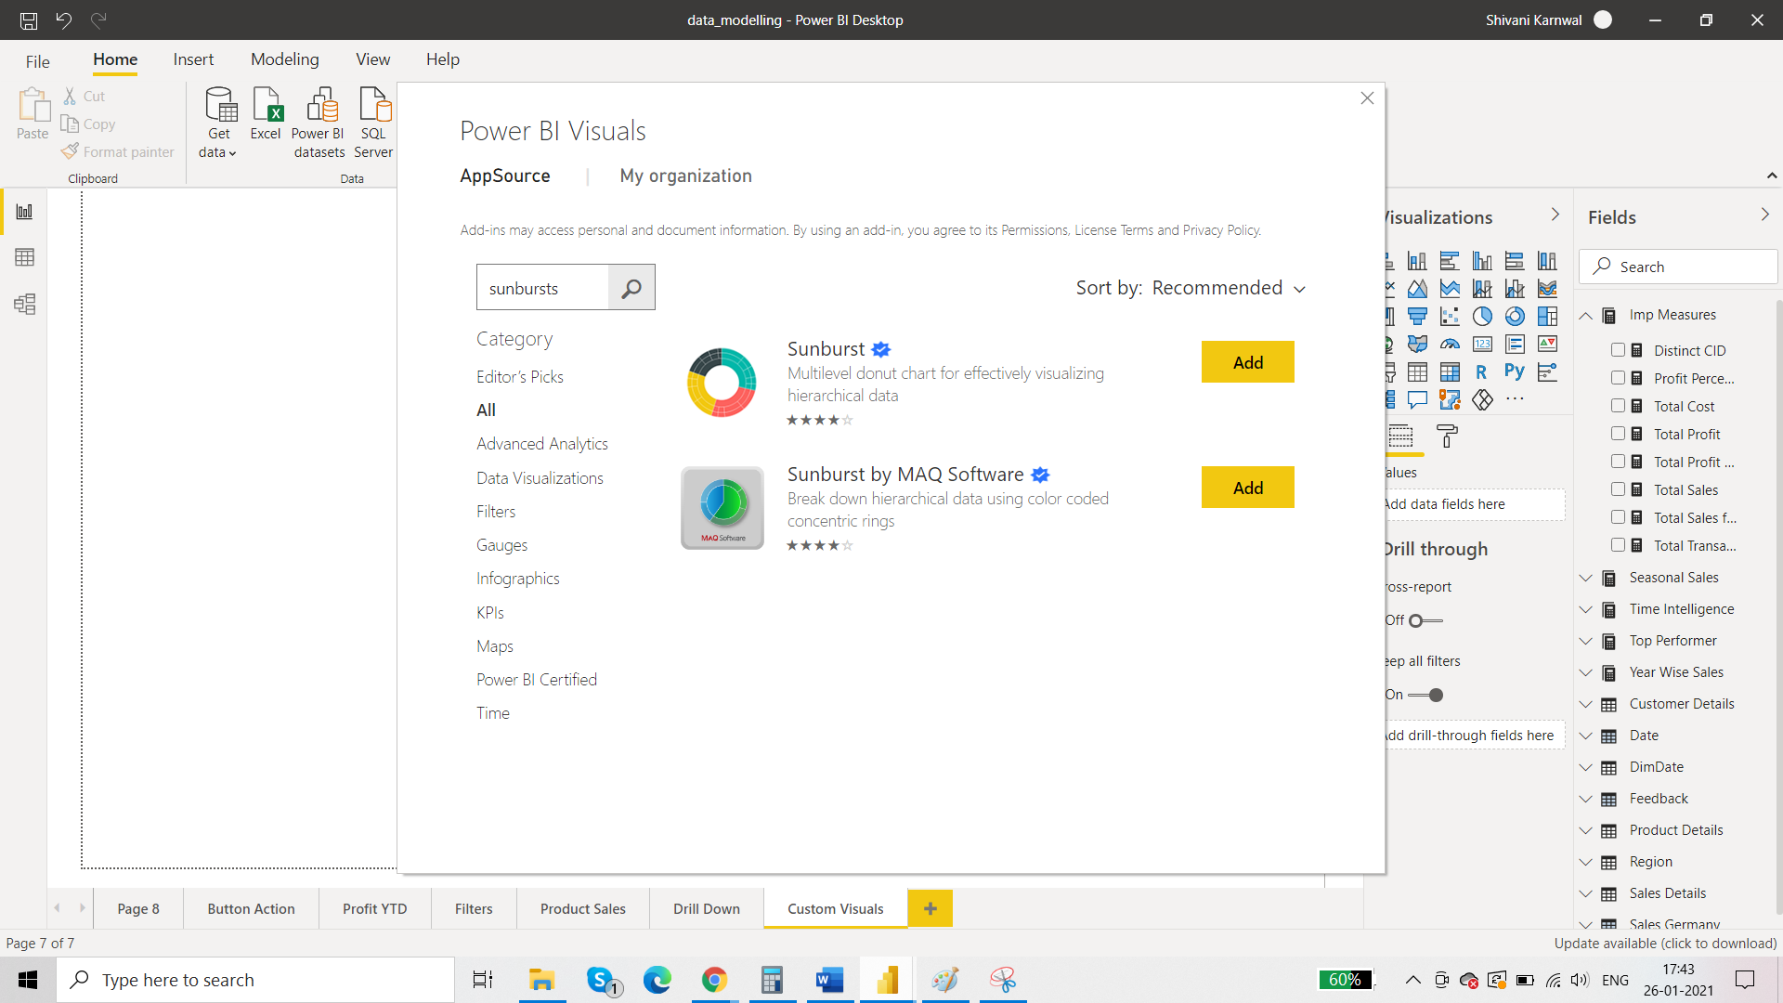

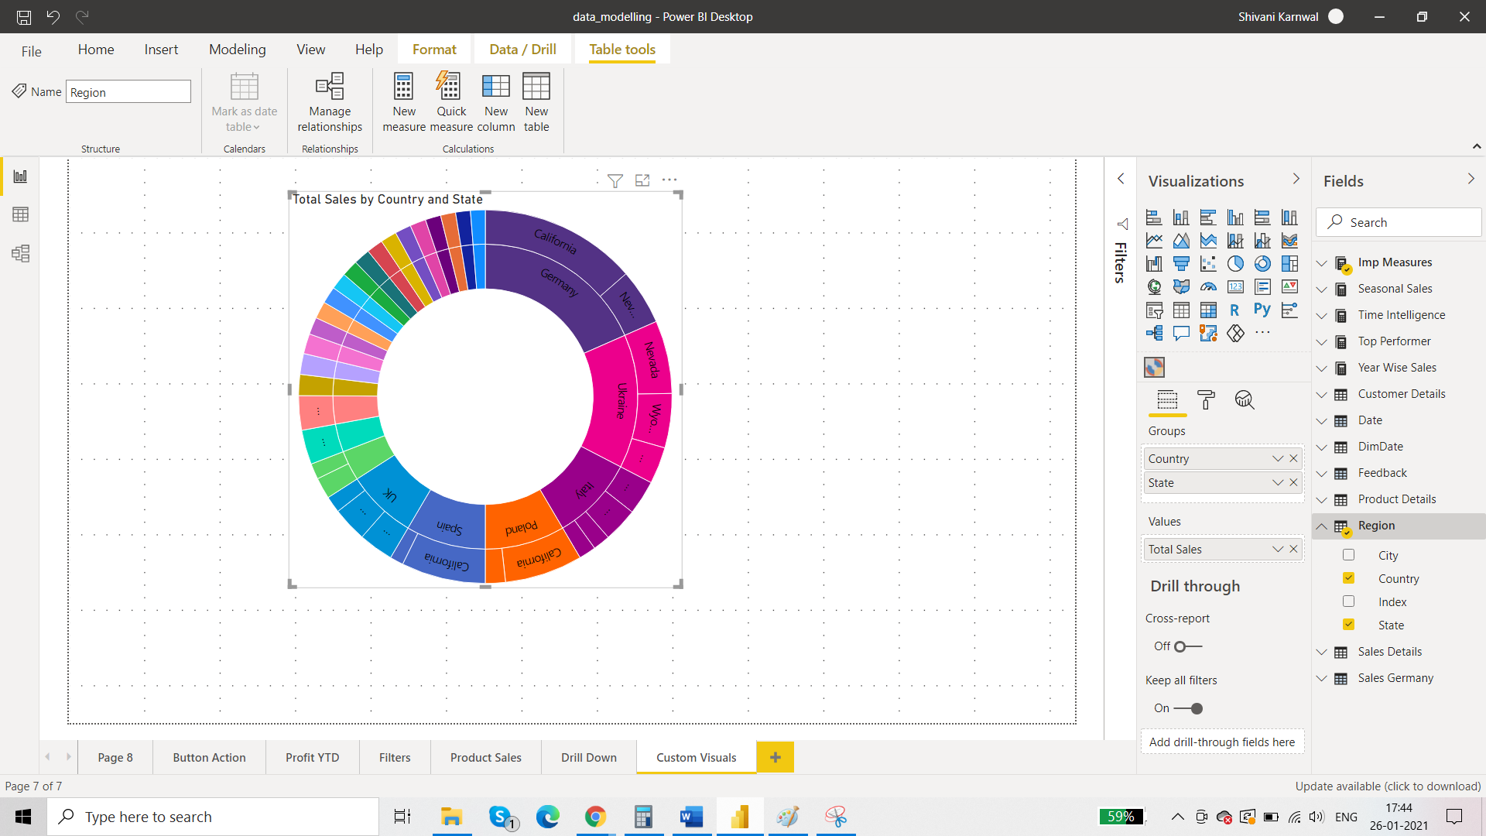

Flags for countries in place of name in the slicer: implementation of custom visual

Duplicate the previous dashboard.

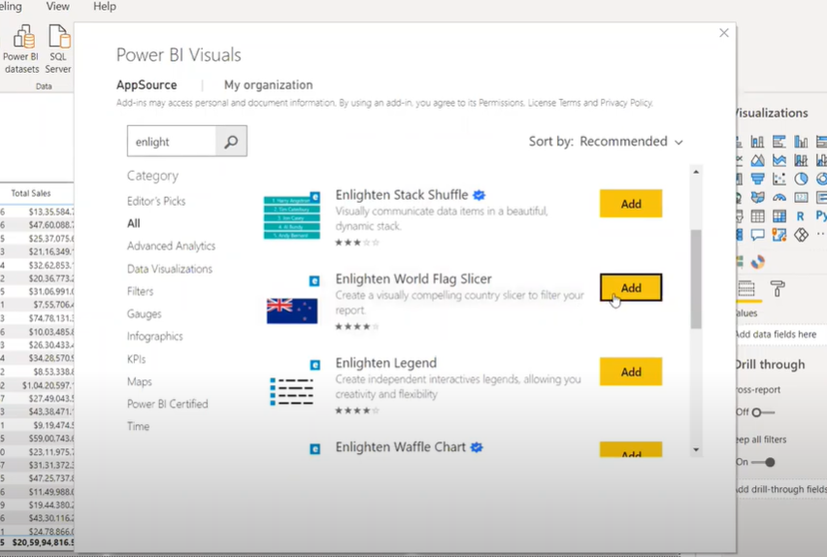

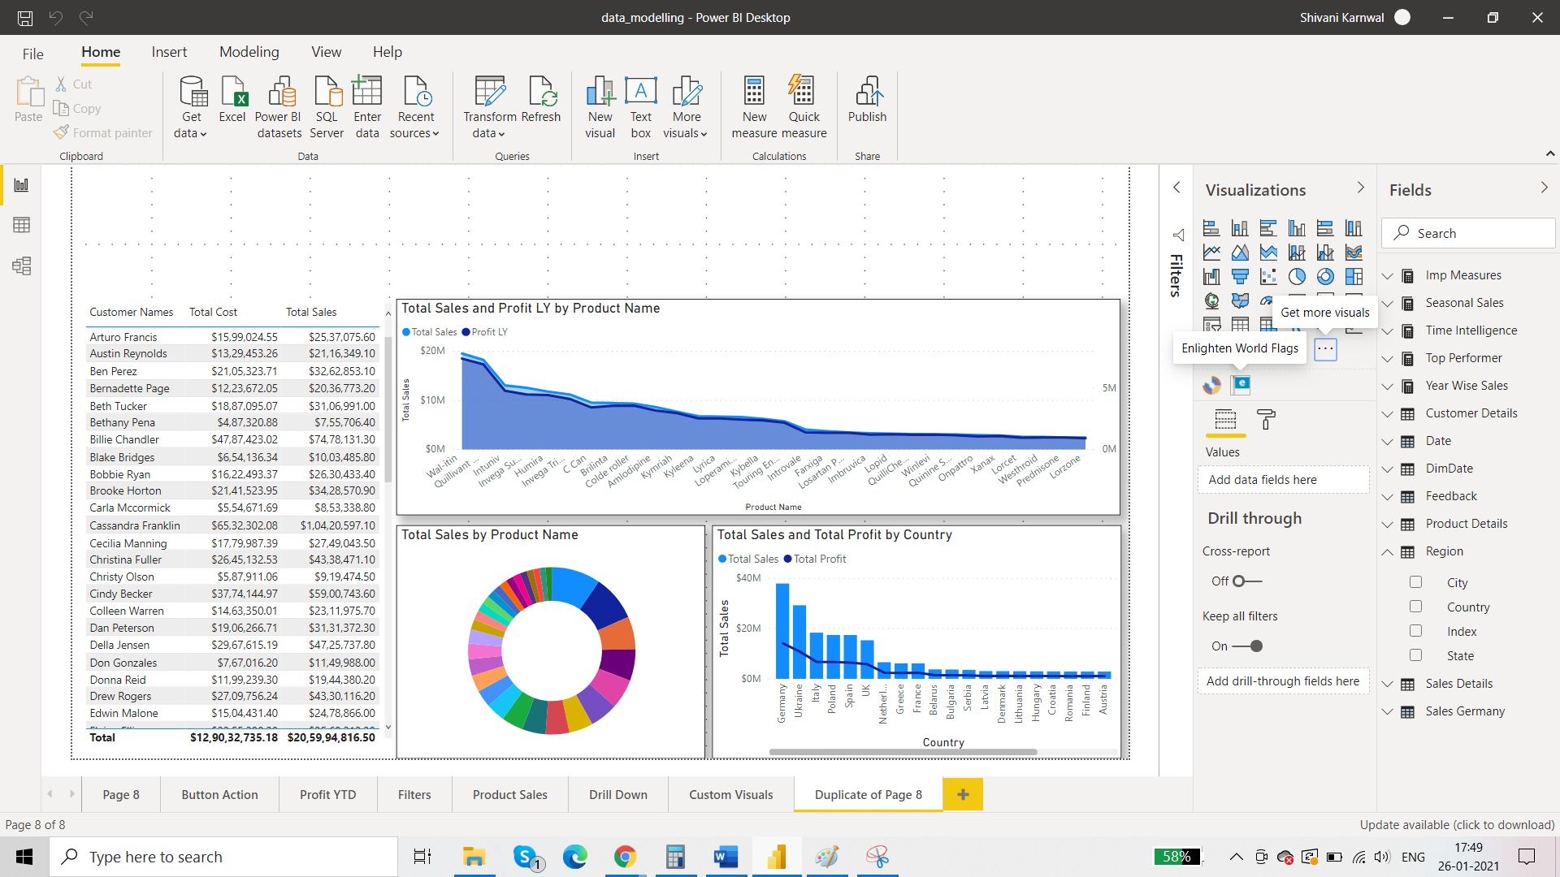

**Card Image**

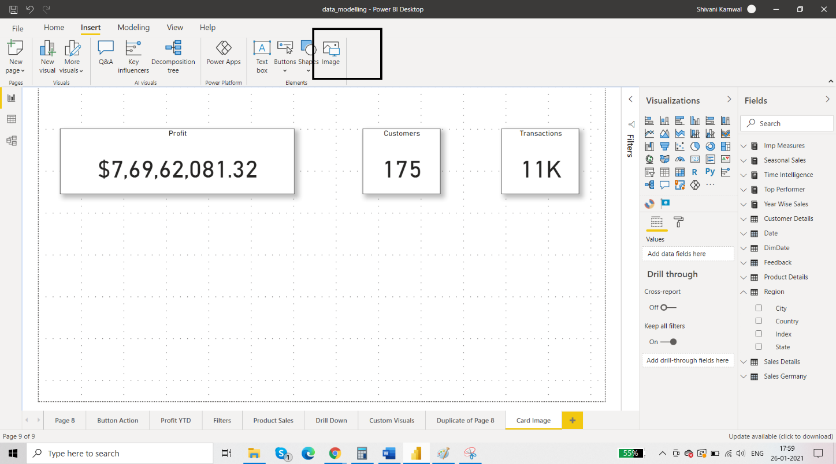

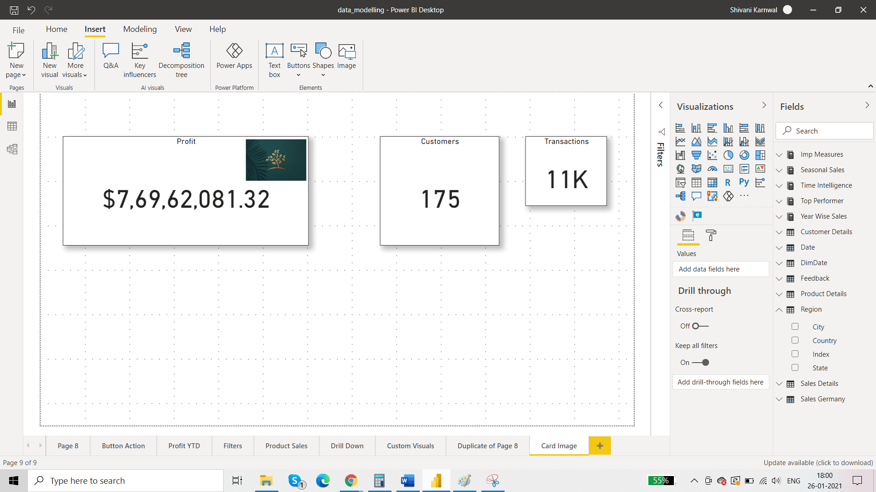

# **Create a Q&A visual in Power BI**

Q&A takes three attributes:

* Tables
* Measures
* Columns

The Q&A visual allows users to ask natural language questions and get answers in the form of a visual. Consumers can use it to quickly get answers to their data. Designers can also use it to create visuals quickly. If you're a report designer, this article is for you. You can double-click anywhere on a report and use natural language to get started. In this article, you create, format, and customize a Q&A visual. It supports themes and other default formatting options available inside Power BI. After you create it, it behaves like any other visual, supporting cross-filtering, cross-highlighting, and bookmarks.

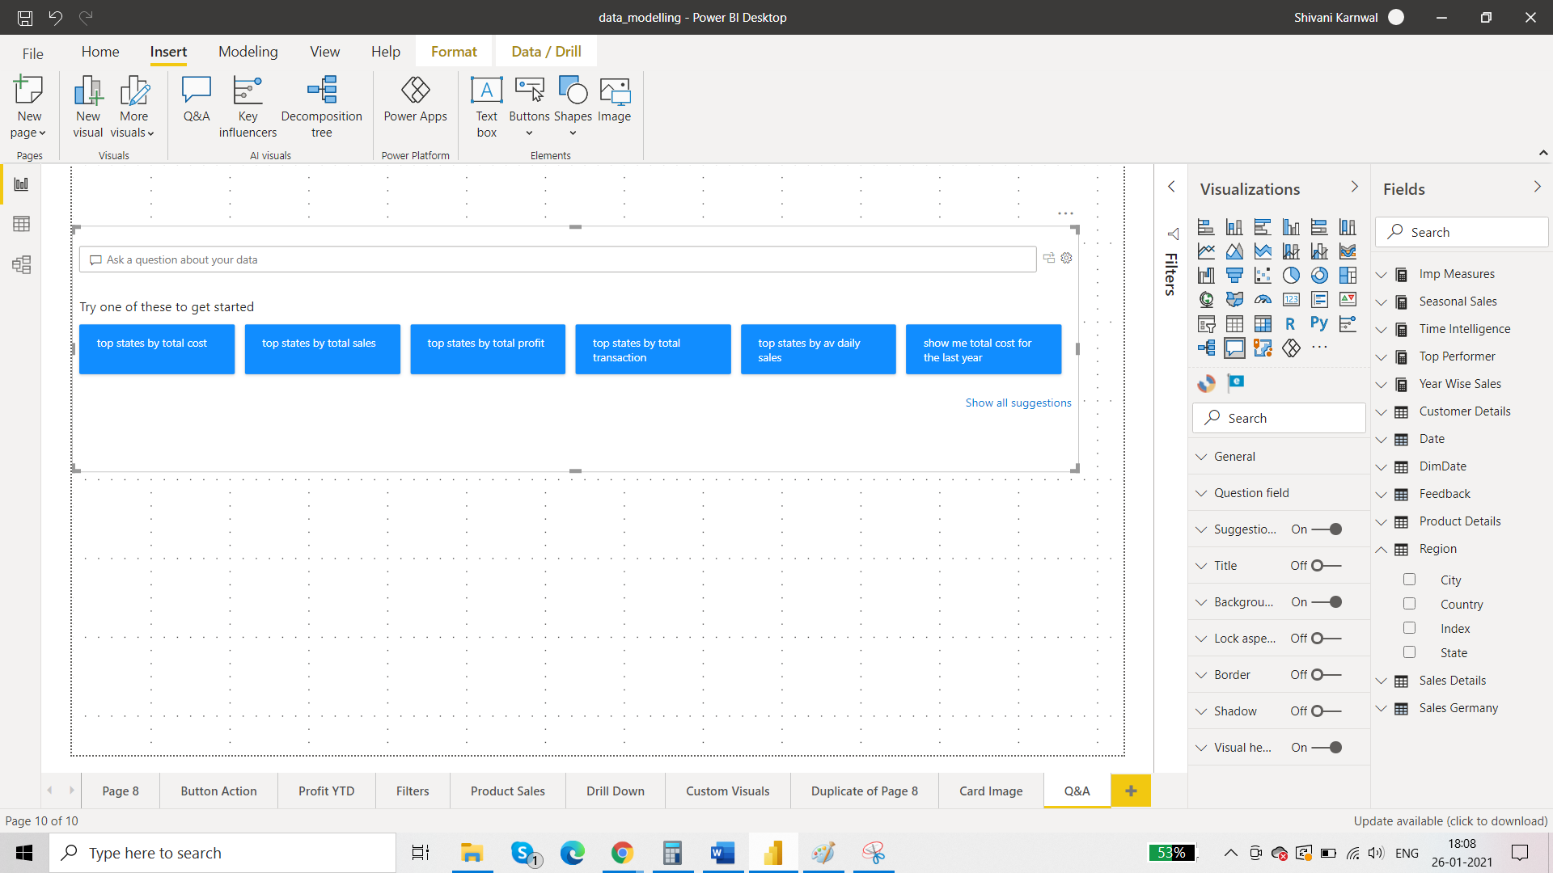

For example: you want to create total sales for different customers.

So search for total sales.

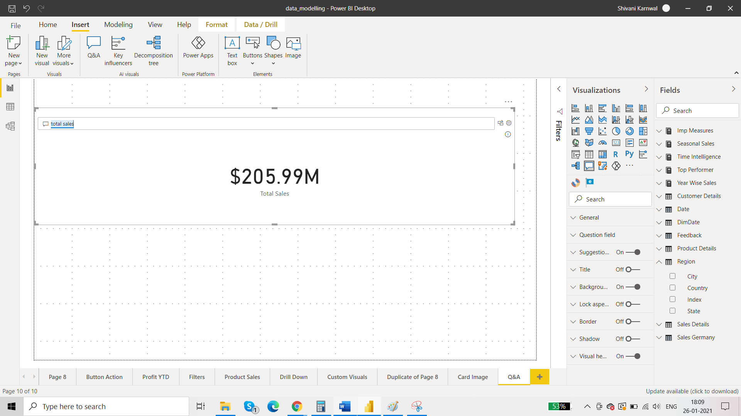

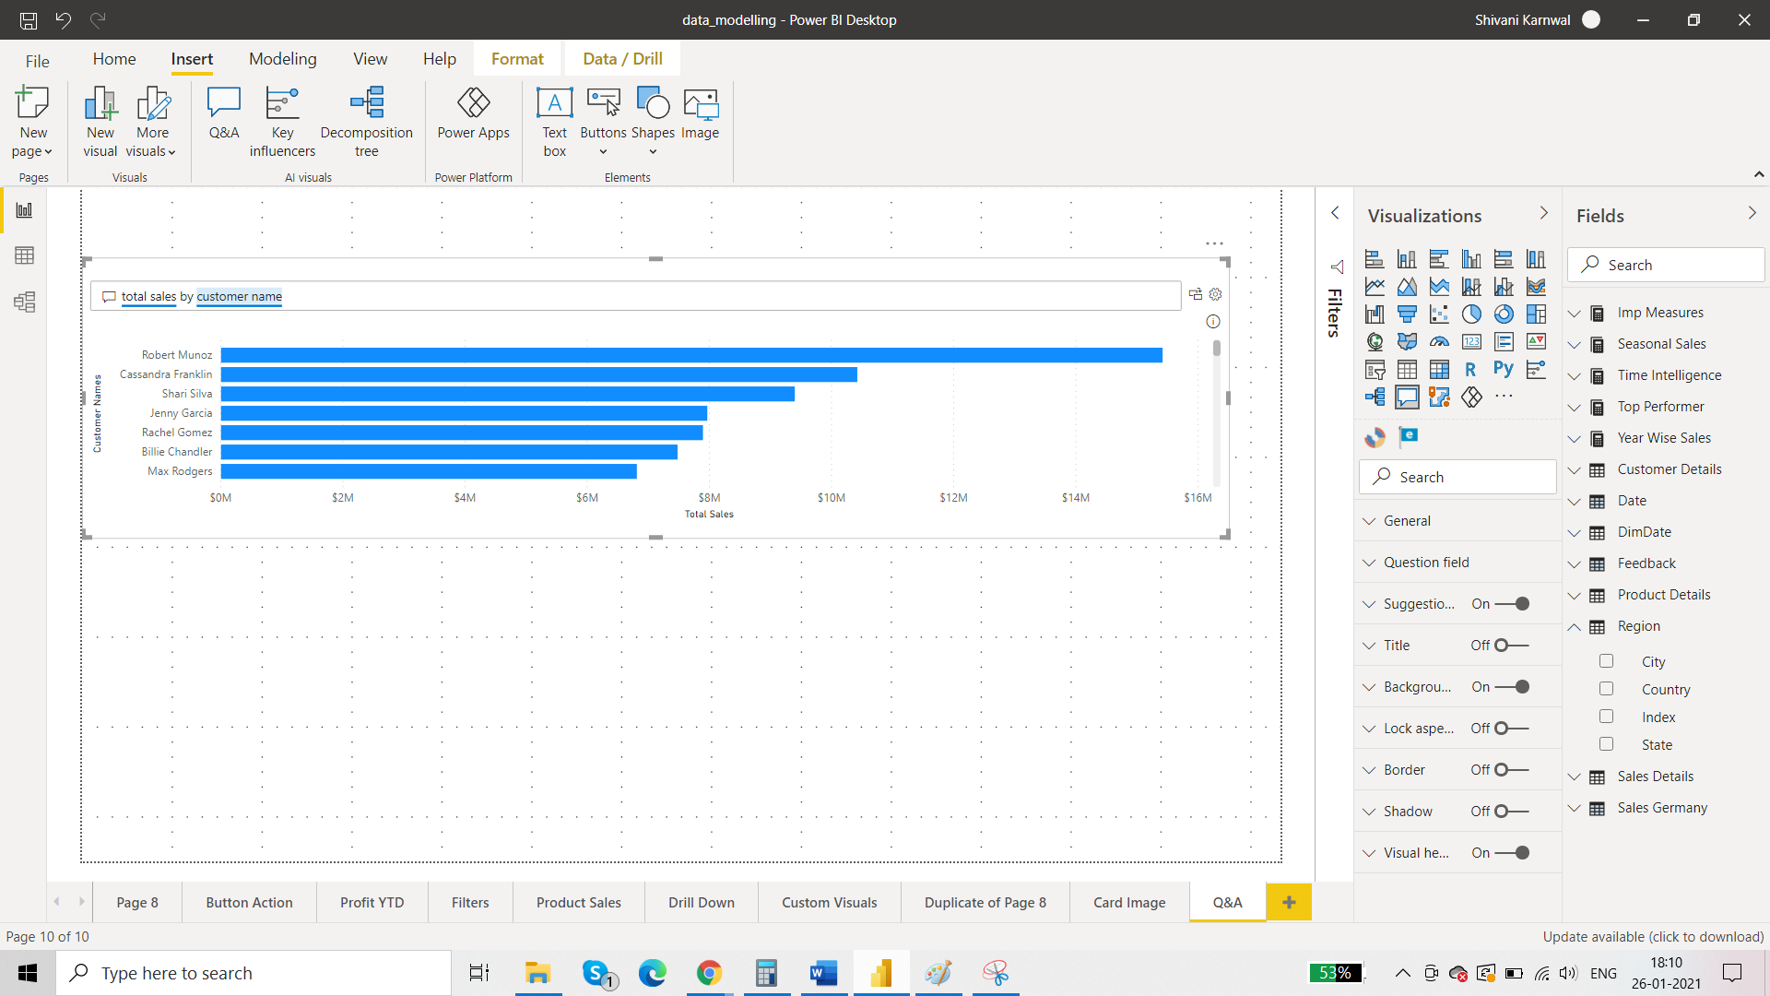

You can change the type of visual by using ‘as’ in the search bar.

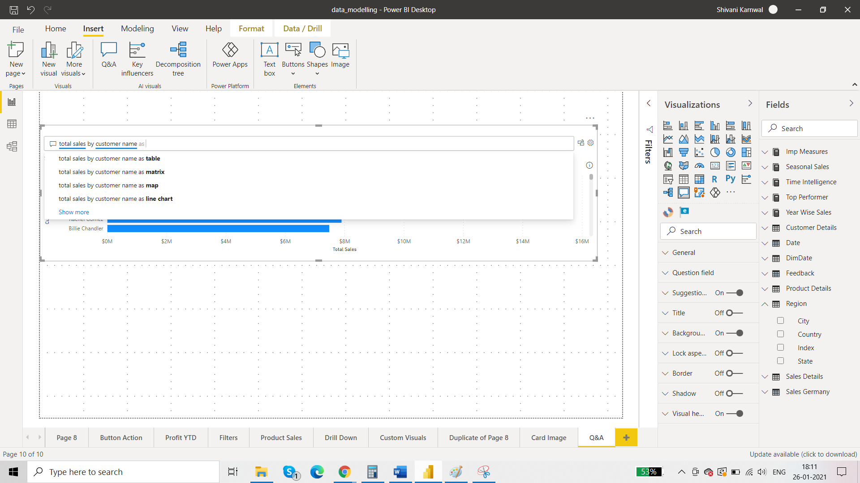

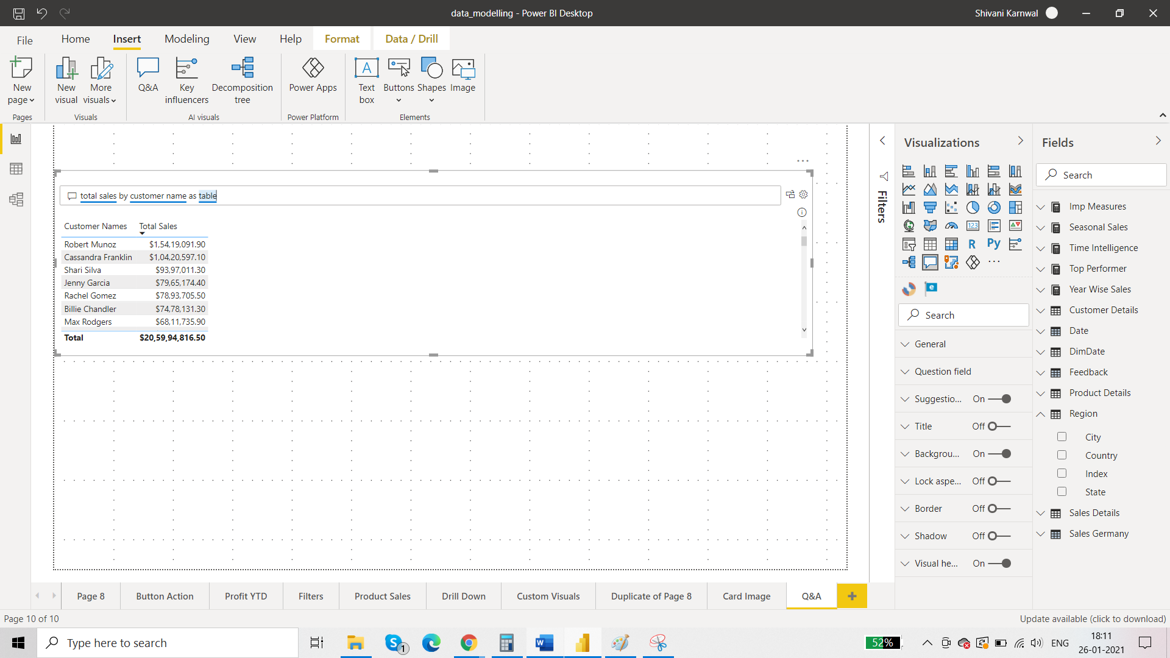

You can convert this q&a into visual.

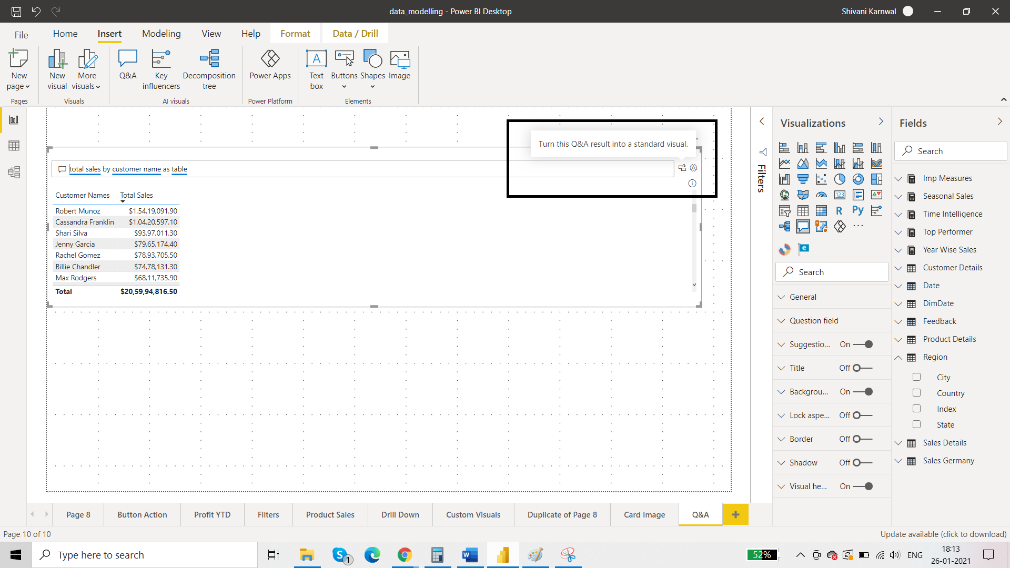

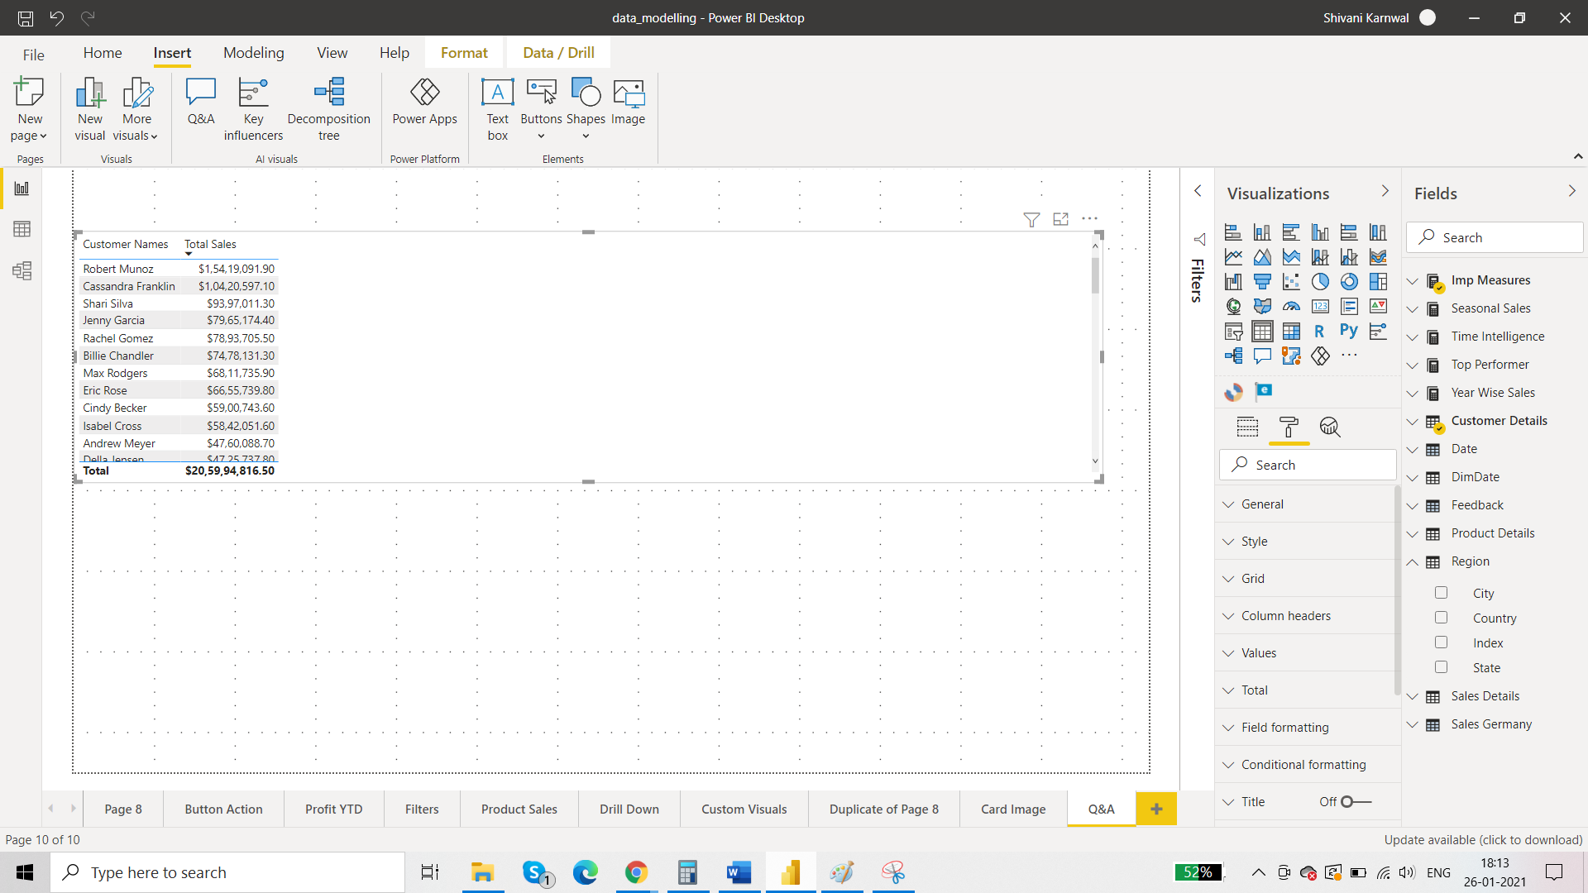

Q&A works in power bi service too.